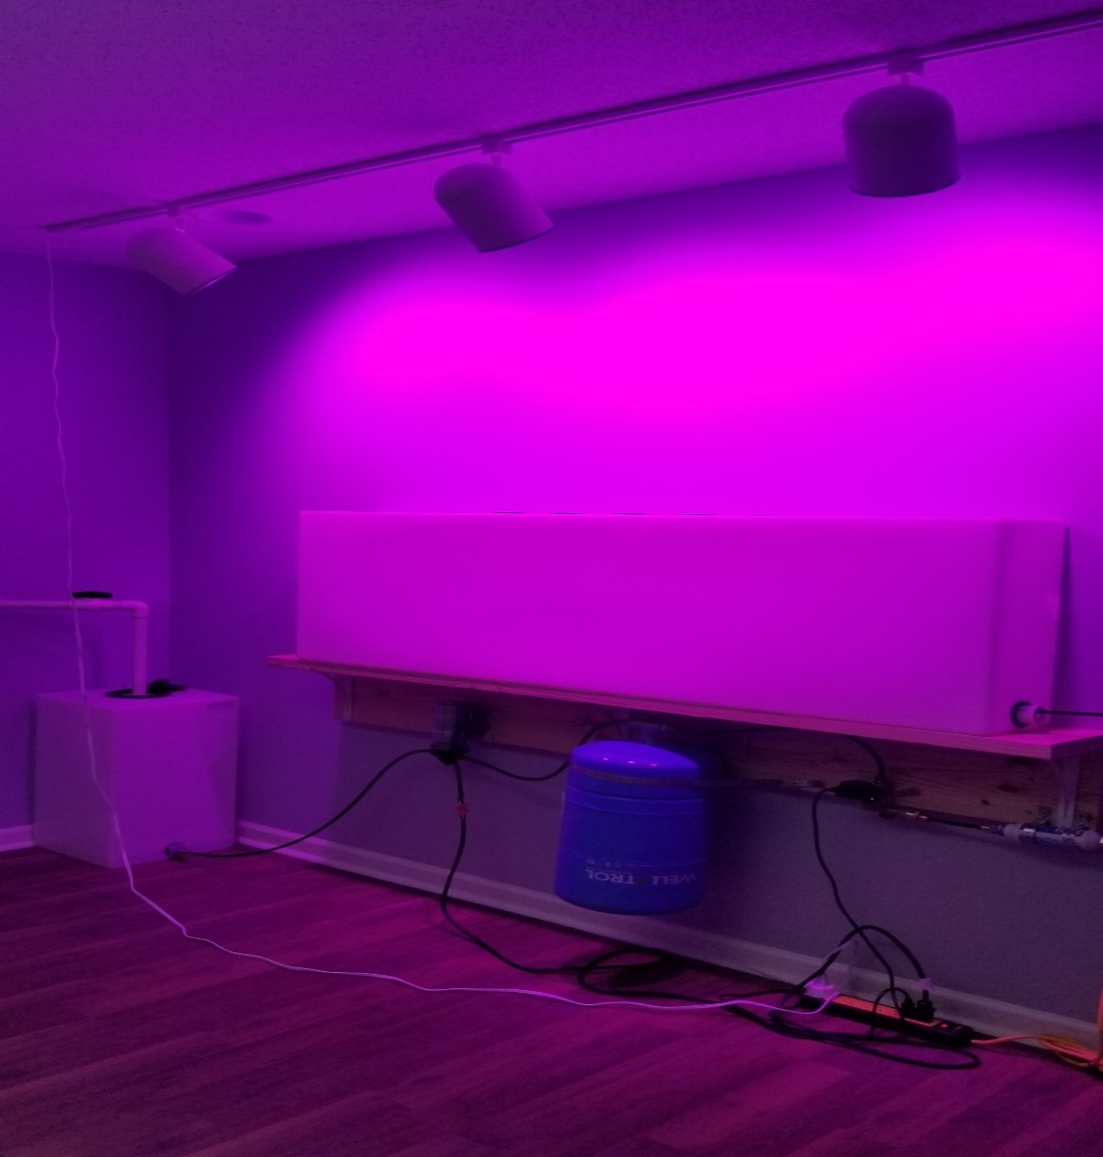
AALS Phase 1 Introduction
In December of 2019, researchers in the Department of Agricultural Engineering at the University of Brawijawa in Indonesia published a paper on their development of a system intended to be implemented in the management of micro-climates such as those seen in a greenhouse. The researchers surmised that the benefit of using microcontrollers to manage these systems was a substantially low occurrence of errors recorded in the underlying parameters utilized in system control. Such systems are characterized by their efficiency and economy of size, energy usage and overall cost due to their small form factor. These are all highly relevant considerations as the current global pandemic has placed an insurmountable strain on supply chain management. As the supply chain crawls, provision of subsistence food items become scarce in local grocery stores. Small-scale high pressure aeroponics systems would be a means of alleviating this strain for individuals willing to grow their own food. As the willingness of private citizens to undertake the task of engaging in such an enterprise is dependent on simplicity and availability, it is imperative that such systems be small, affordable, efficient, inexpensive, and easy to use. A home high-pressure aeroponics module automated by a microcontroller, is a means of producing a “farm in a box” product with push-button functionality. Such a product would be a highly-adoptable technology destined for quick success on the market.
Automated Aeroponics Laboratory is a three phase research project identifying the viability of a “farm in a box” high-pressure aeroponics system. In each of three consecutive phases, a microcontroller will be designed through iterative prototypes that will automate those activities involved in the tending of growth cycles from seed to harvest. This includes the management and scheduling of the provision of light, nutrients, and warmth. In the first phase of AALS research, outlined in this presentation, the back end functionality was architected. The process of architecting the receipt and storage of sensor data from the microcontroller included requirements gathering, software development lifecycle planning iterative development and testing, and concluded with product release.

